John Paul Limos

W4D1 Homework



1. Design the tables in database, attention their relationship and the constraint (primary key, foreign key)

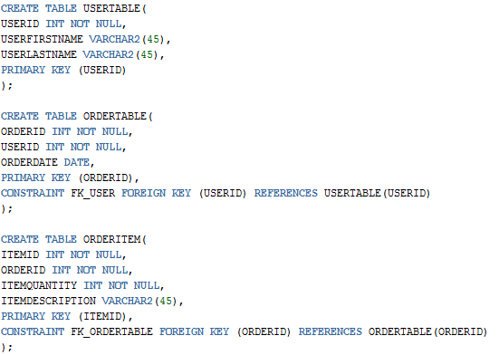

1. What are DQL, DML, DDL and DCL for Database? And what their commands? And give examples for each one based the above tables “User”, “Order” and “OrderItem”.

**DQL** – Data Query Language. Usually used to view rows/records for tables.

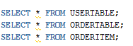

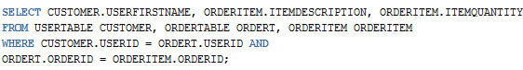

**DML** – Data Manipulation Language. Used for manipulating the rows/records in a table.

**Insert**

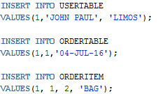

**Update**



**Delete**



**DDL** – Data Definition Language. Used to define data structures (usually for tables)

**Create**



**Drop**



**Alter**

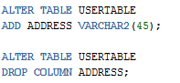

**Rename**



**DCL** – Data Control Language. Allows database administrators to configure security access to relational databases.

**Grant**



**Revoke**



**Rollback**



**Commit**

